St. Francis Institute of Technology, Mumbai-400 103

**Department Of Information Technology**

A.Y. 2024-2025

Class: TE-ITA/B, Semester: V

Subject: **DevOps Lab**

**Experiment – 2: To understand version control system/ source code management, install git and create a GitHub account**

1. **Aim:** To understand version control using Git and create a GitHub account
2. **Objectives:** Aim of this experiment is that, the students will be able

* To be aware of different Version Control tools like GIT and GitHub
* To obtain complete knowledge of the “version control system” to effectively track changes augmented with Git and GitHub

1. **Outcomes:** After study of this experiment, the students will be able to

* GIT Installation
* Version Control
* Working with remote repository

1. **Prerequisite:** Knowledge of software engineering concept of version control
2. **Requirements:** Git,Personal Computer, Windows operating system, browser, Internet Connection, Microsoft Word.
3. **Pre-Experiment Exercise:**

**Brief Theory:** Refer shared material

1. **Laboratory Exercise**
   * + 1. **Procedure:**

**a. Answer the following:**

* Explain version control and its types

=Version control is a system that tracks changes to files over time, helping manage and collaborate on projects. The main types of version control systems are:

1.Local Version Control Systems (LVCS): Store changes on a local machine (e.g., RCS).

2. Centralized Version Control Systems (CVCS): Use a central server to store all file versions (e.g., CVS, SVN).

3. Distributed Version Control Systems (DVCS): Each developer has a complete copy of the repository (e.g., Git).

Key features of Git (a DVCS):

Distributed Model: Full repository copies on each developer's machine.

Branching and Merging: Easy creation of separate development lines and integration of changes.

Remote Repositories: Hosted versions for collaboration (e.g., GitHub).

Staging Area: Intermediate space for preparing commits.

* What is Git and GitHub?

=Git is a mature, actively maintained open source project originally developed in 2005 by Linus Torvalds, the famous creator of the Linux

operating system kernel.Git is a free and open source distributed version control system designed to handle everything from small to very large projects with speed and efficiency.

GitHub is a cloud-based hosting service for Git repositories. It provides a web interface for managing Git repositories and offers additional features such as issue tracking, code review, and project management tools.

* Explain different Git commands

1. git --version:shows the current version of git .

2. git init:Initializes a new Git repository in the current directory.

3. git status:Shows the status of changes in the working directory and staging area.

4. git config:let us set a new name that will be visible in any future

commits you push to GitHub from the command line.

5. git add:Stages changes for the next commit.

6. git commit:Commits staged changes to the repository with a descriptive message.

7. git log:Shows the commit history for the repository.

**b**. **Execute following on Git and GitHub (Refer the shared material) and attach screenshots:**

* Git installation
* Git commands
* GitHub account creation

1. **Post-Experiments Exercise**
2. **Extended Theory:**

Nil

1. **Questions:**

* What are the different Git areas? Explain with diagram
* What is a Git conflict?

1. **Conclusion:**

* Write what was performed in the experiment.
* Write the significance of the topic studied in the experiment.

1. **References:**

[**https://github.com/**](https://github.com/)

[**https://guides.github.com/activities/hello-world/**](https://guides.github.com/activities/hello-world/)

[**https://git-scm.com/docs/gittutorial**](https://git-scm.com/docs/gittutorial)

**GIT Installation:**

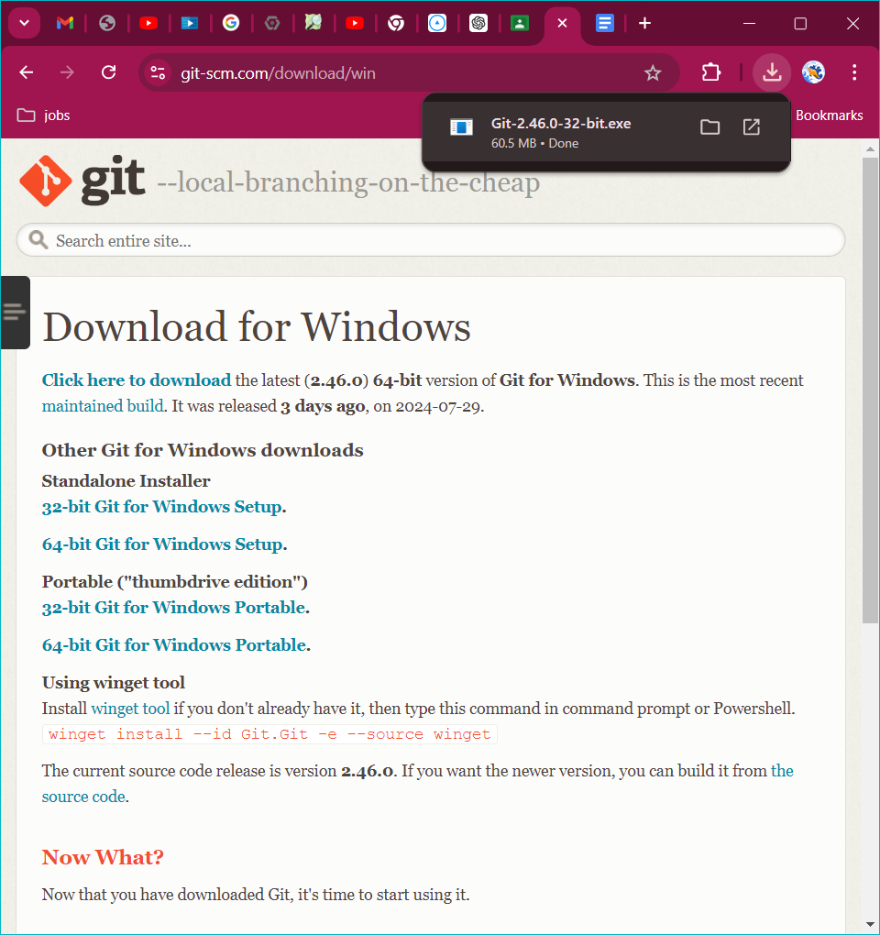

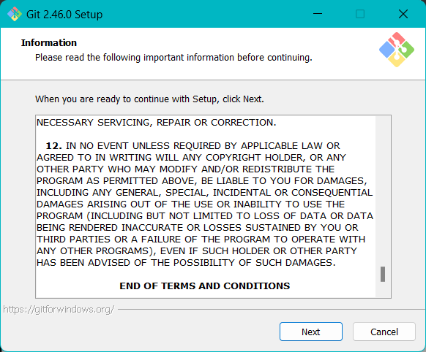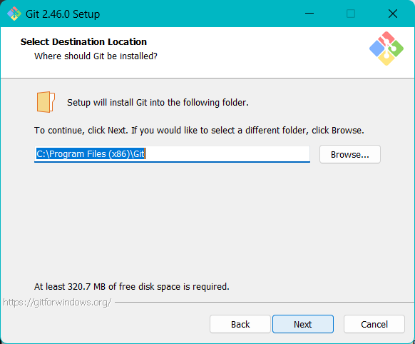

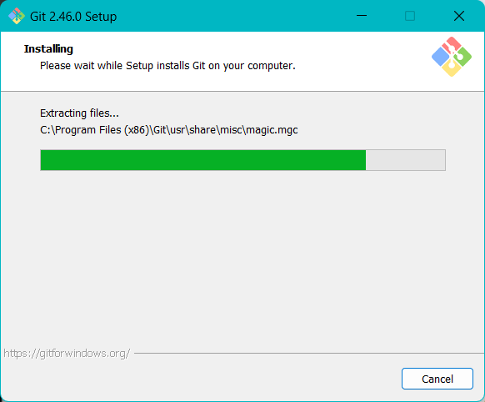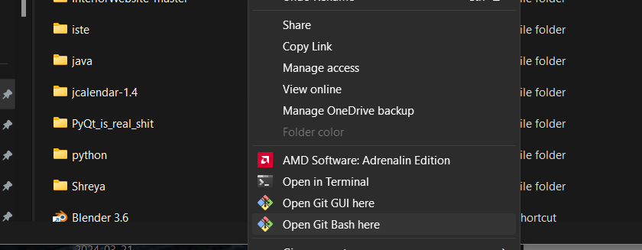

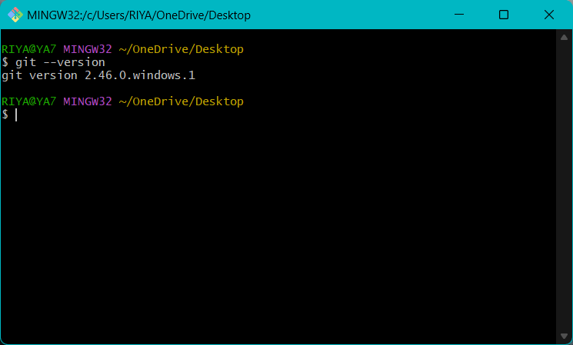

**GIT COMMANDS:**

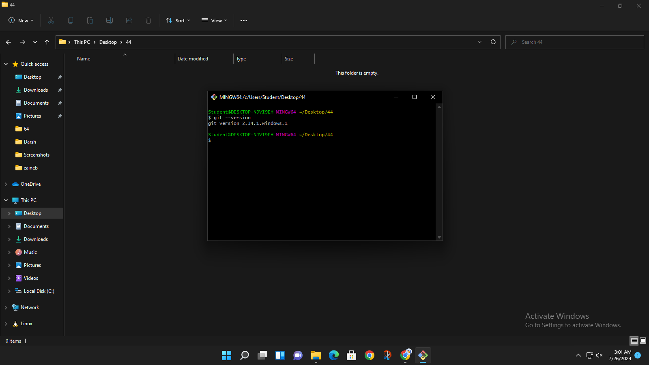

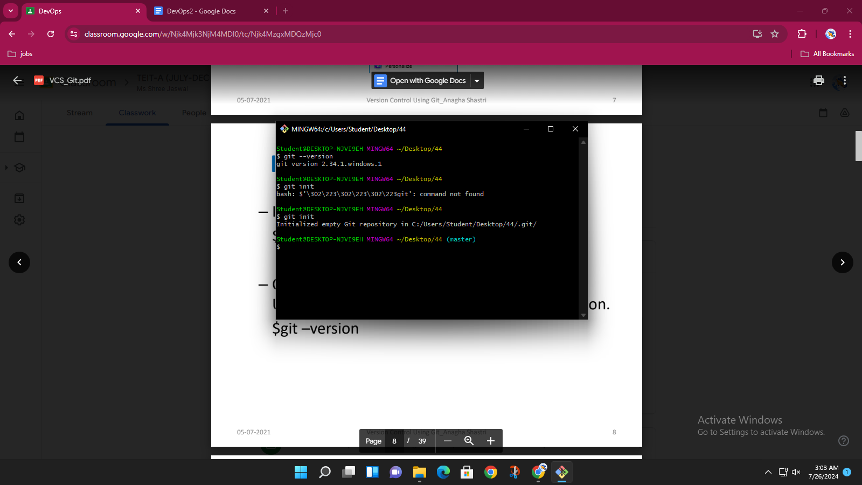

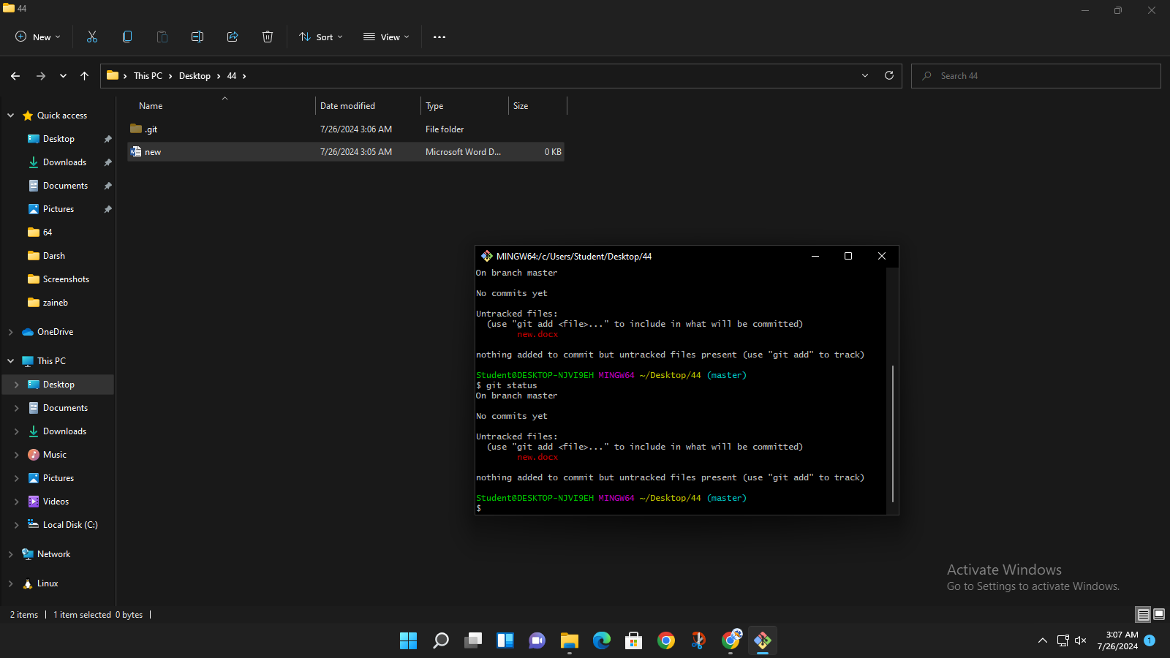

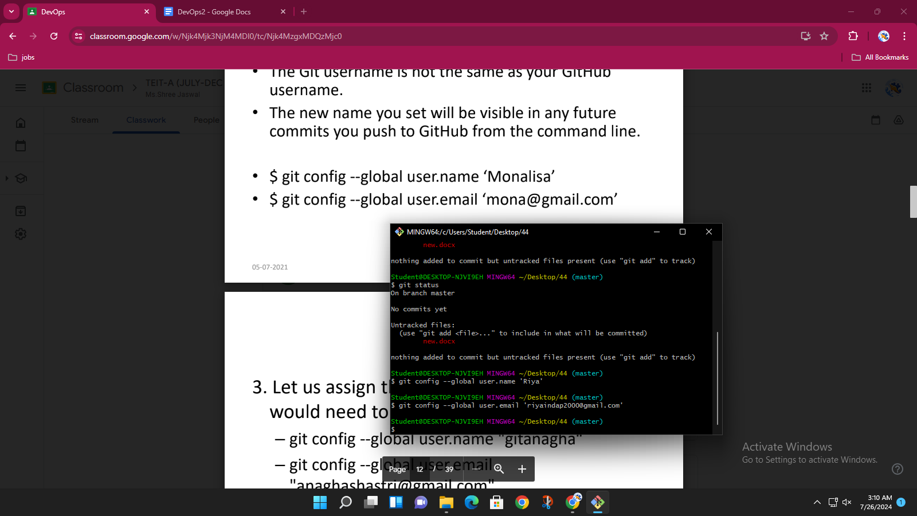

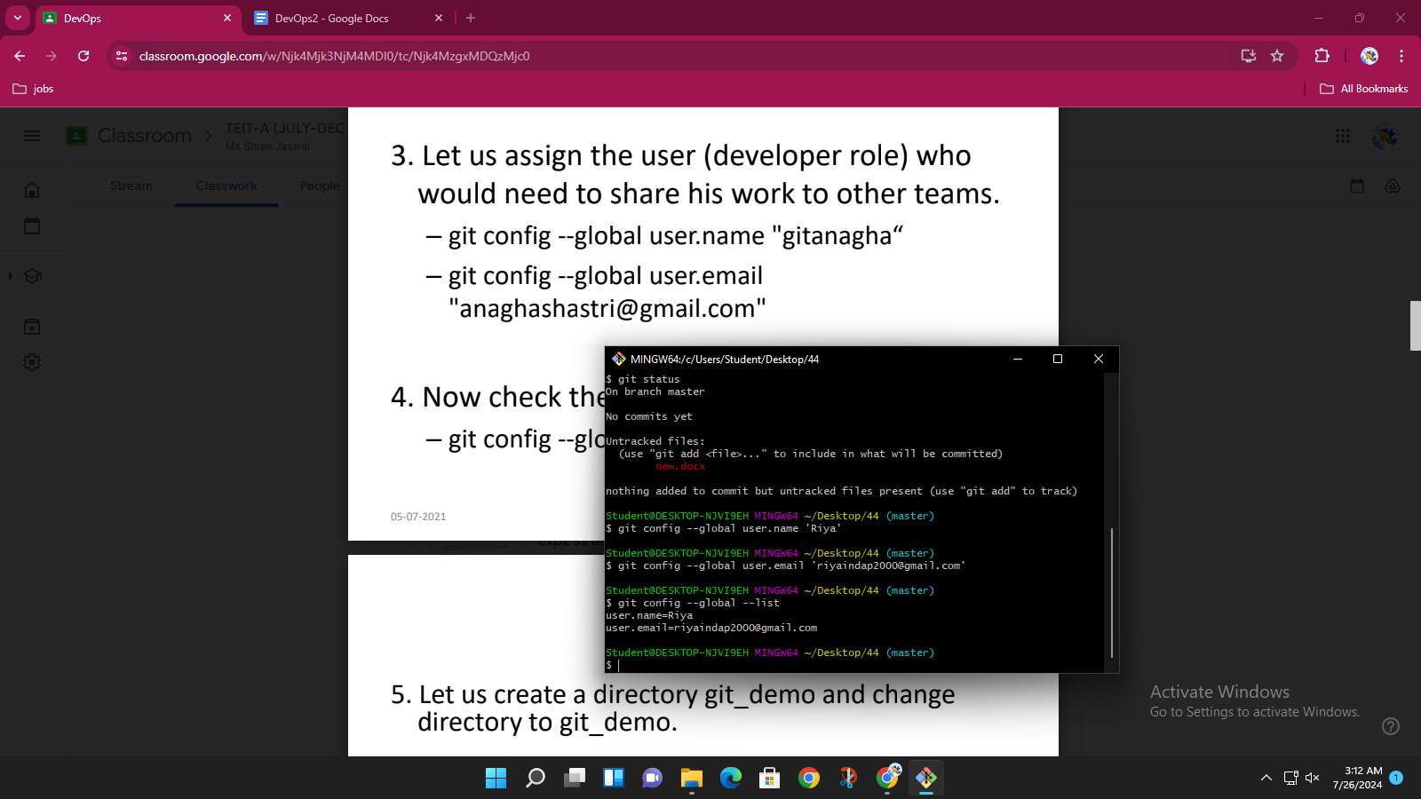

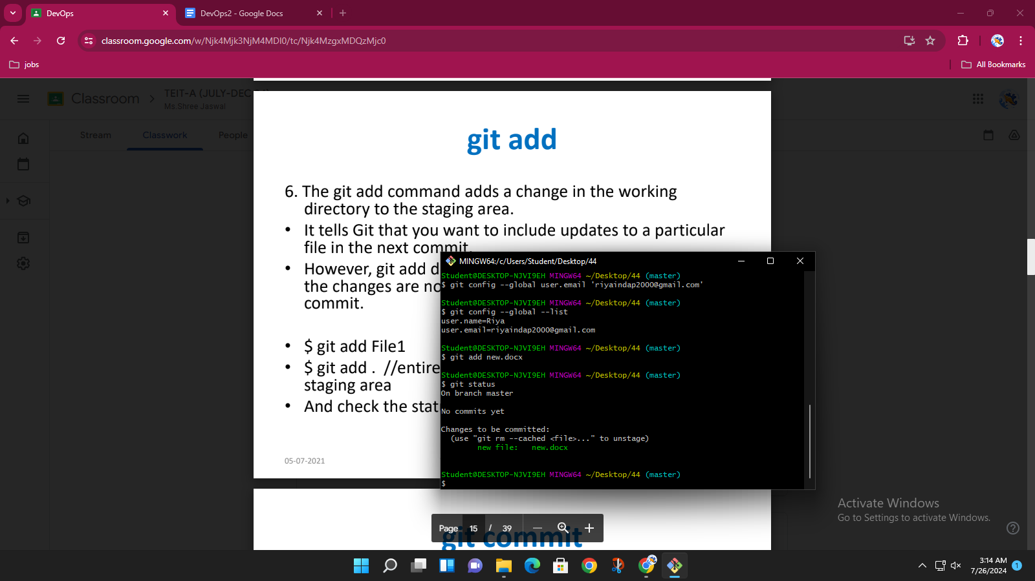

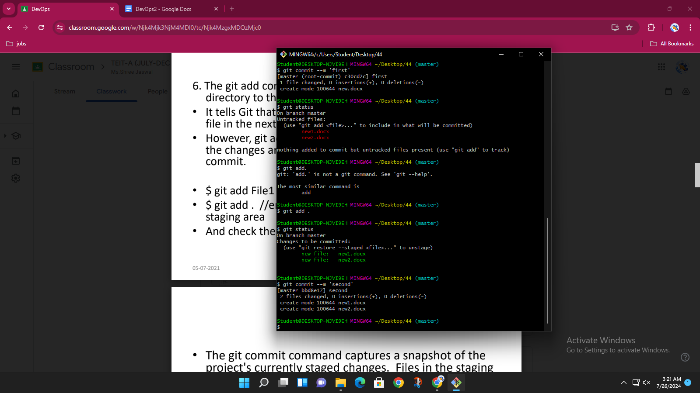

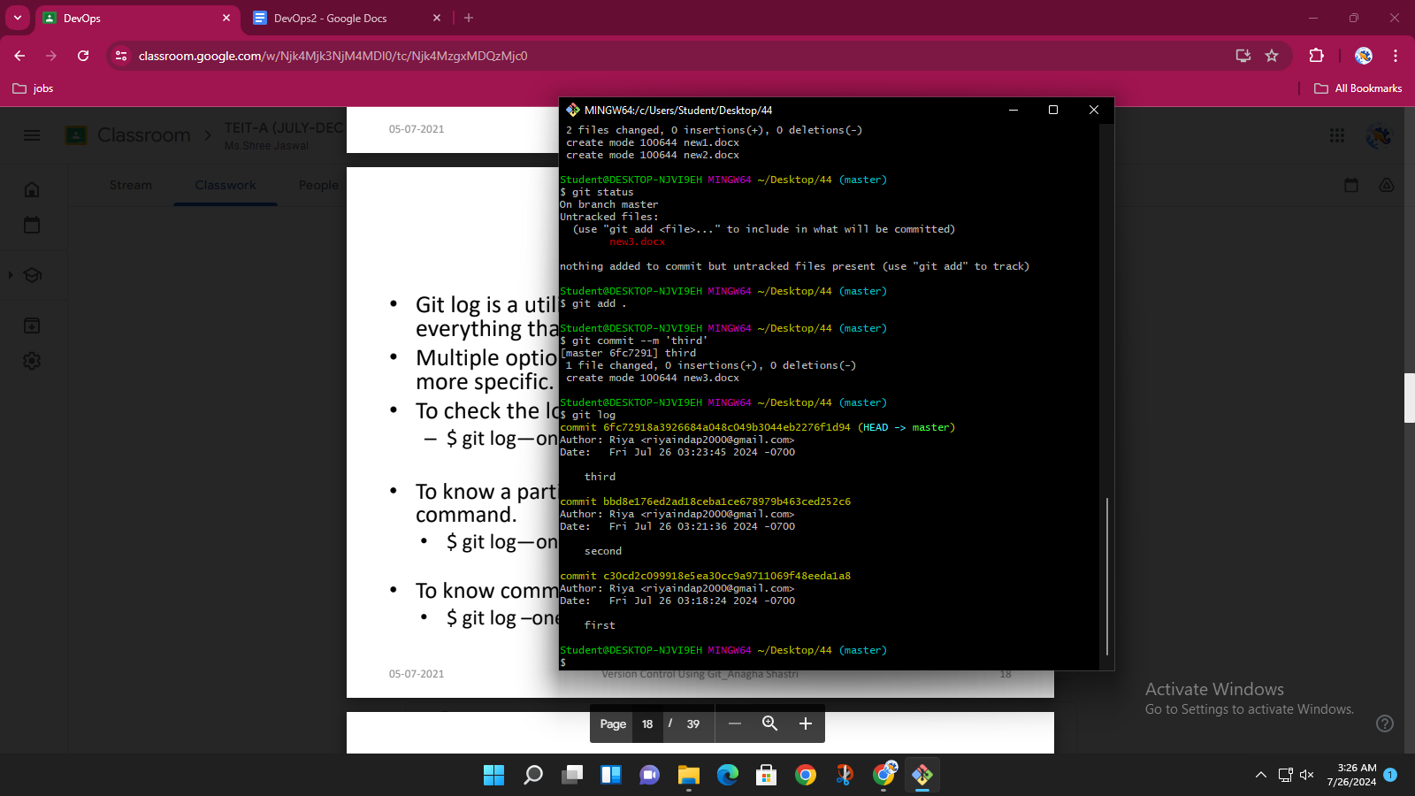

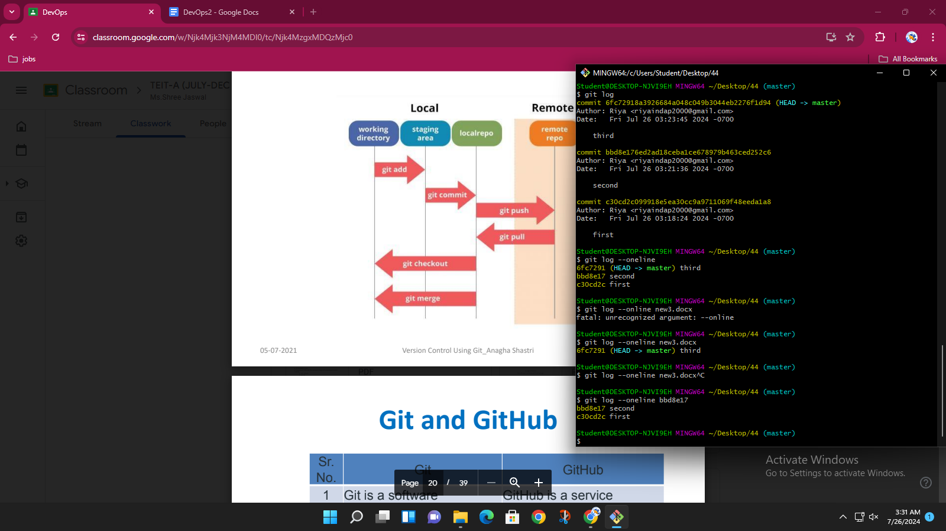

**GITHUB ACCOUNT CREATION:**

